Assignment: Applied Statistics in Excel
Data: https://github.com/TopsCode/Data_Analysis_2024/blob/main/ALL_CSV/airline_passenger_satisfaction.csv

1. Mean of Column Data
2. Median of Column Data
3. Variance, Standard Deviation and Standard Error
4. Decide the Shape of Distribution

Ans:
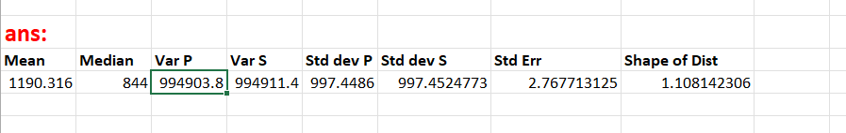

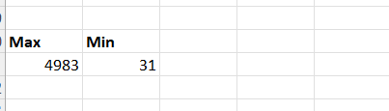

5. Find Outliers
Ans:
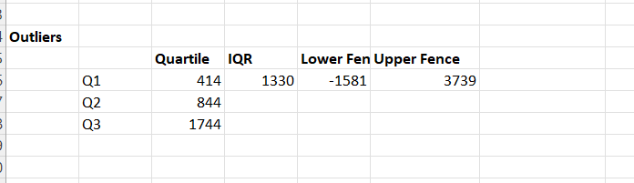

6. Graph the Column Data and Comment
Ans:

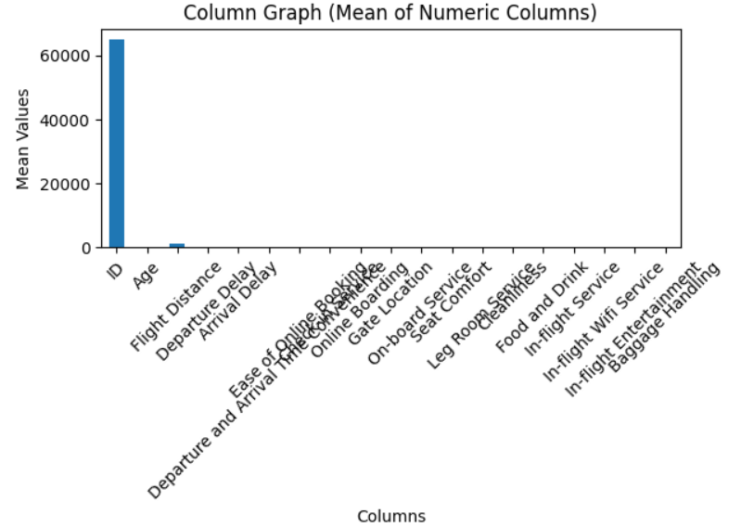

7.Boxplot
Ans:
